Birla Institute of Technology & Science, Pilani
Work Integrated Learning Programmes Division
First Semester 2022-2023

Comprehensive Test
(EC-3 Makeup)

Course No. : DSECL ZC556
Course Title : Stream Processing and Analytics
Nature of Exam : Open Book
Weightage : 40%
No. of Pages = 3

No. of Questions = 6
Duration : 2 Hours
Date of Exam : 06/03/2021 or 19/03/2021 (FN/AN)
Note to Students:
- Please follow all the Instructions to Candidates given on the cover page of the answer book.
- All parts of a question should be answered consecutively. Each answer should start from a fresh page.
- Assumptions made if any, should be stated clearly at the beginning of your answer.

Q1. Stream S1 has attributes “x” and “y”. Stream S2 has attributes “x” and “y”. Both streams have a common attribute “id”. The two streams are joined based on “id” attribute. Window of size 2 is mentioned on both streams. The streaming query is defined as follows -

Select s1.x % 3, s2.y % 4
From S1 as s1 join S2 as s2
On s1.id = s2.id

Provide the outcomes of the joins with each step of the execution. (Pictorial representation is must). [10]

Stream S1
Time | Event | Id | X | y
T1 | E1 | 0 | 3 | 5
T2 | E3 | 1 | 6 | 8
T5 | E5 | 2 | 4 | 3
T6 | E6 | 3 | 7 | 3
T9 | E7 | 4 | 15 | 3

Stream S2
Time | Event | Id | X | y
T2 | E2 | 1 | 3 | 5
T4 | E4 | 2 | 3 | 3
T7 | E7 | 3 | 4 | 8
T8 | E8 | 4 | 9 | 3
T10 | E10 | 5 | 20 | 4

Q2. Consider the following stream of tweets for the IPL and FIFAWorldCup (FWC) released recently. Determine the trending event using the appropriate technique discussed in the class. Initial weight is 2.5 and constant factor as 0.03. [5]

Event stream – FWC, IPL, IPL, FWC, FWC, IPL, FWC, IPL, IPL, FWC

Q.3. Write pseudo code for the streaming version of algorithm to compute the range of data values from the given stream of data elements. Show its execution for the data values – 2, 4, 1, 0, -4, 3, -5, 2, 1, 0, -4 and 0. [5]

Q.4. Answer the following Bloom Filter design sub questions – [3 + 2 + 1 + 2 + 2 = 10]
You are appointed as a data engineer require to propose a searching mechanism based on Blooms filter. For this Bloom filters False Positivity rate is given by the formula

(1 – exp ( -nk/m ) )^{k}

Where m represents number of elements in the stream under consideration, n is actual storage capacity of the filter and k is number of hash functions used.

The filter capacity estimated to be 6 MB. Over period of time the filter could store 10⁶ events using 3 hash functions

- Estimate the false positive rate of the filter with given parameters.
- What is the False Positivity rate if filter capacity is changed to 60 MB, keeping other parameters same?
- What can be the conclusion drawn from part (a) and (b) above?
- If optimal number of hash functions is given by following formula, what is optimal number of hash functions needed to build this Bloom filter?
k_{opt} = (m/n) ln2
- What is the main disadvantage of this filter design in part (d)? How do we correct it?

Q5 Rishkesh’s business owns thousands of Coke vending machines and would like to make them social. He wants his machines to tweet and sent push notifications with special offers to consumers who are geographically close. If the closest vending machine doesn’t have stock to offer, it should recommend the next closest vending machine that can offer the consumer a deal. [4]

- What would happen if link between collection tier and analysis tier is interrupted for an extended period of time? How it can be mitigated? [2]
- Would you anticipate need to store historical data? Why? [1]
- What type of message delivery semantics does this streaming system needs? [1]

Q6 Assume the Apache Kafka cluster setup described by the output of following commands. [1 +1 + 1 + 2 + 1 = 6]

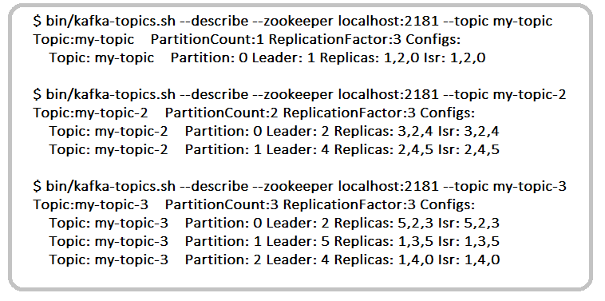
a) How many brokers are present in this system? What are their names?
b) Is it mandatory that all these brokers should reside on separate physical machines? Explain briefly.
c) For topic my-topic-3, what is the maximum number of server failures that this setup can handle?
d) For a topic my-topic-4, what is maximum and minimum number of additional copies of messages can be maintained on this cluster setup with partition count as 1?
e) How many consumer groups can be created for this configuration?

****************************

